OFFICER/CHAIRMAN REPORT
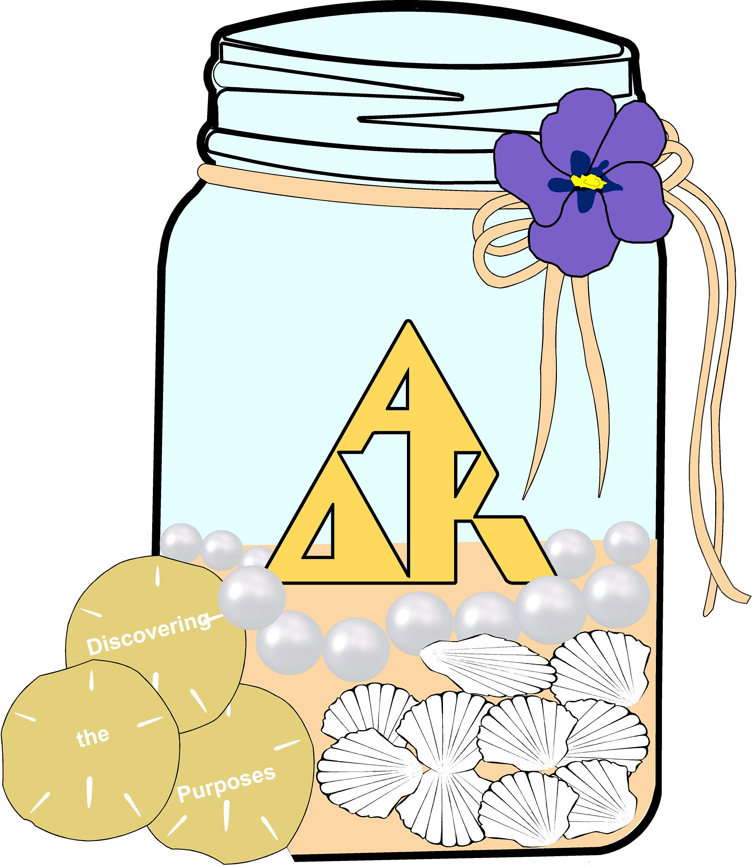
Pat Smith
Columbus District Chairman
2018 - 2020
April, 2020
Officer Responsibilities:
- Organize information and met w/ chapter presidents at the mini retreat in June 18 at Macon, GA.
- Organized and conducted district executive board meetings.
- Helped host chapters in planning district meetings.
- Organized and conducted district meetings.
- Secured state officers for the officer training workshops.
- Responded to emails/phone calls from chapter presidents and district officers in a timely manner.
- Attended state executive board/advisory council meetings to receive info for district chapters and prepare for Fun Day.
- Attended state/district chairmen meeting to prepare for
Fun Day.
- Attended district chairmen/chairmen elect meeting to prepare for state convention.
- Communicated w/chapter presidents regarding required reports, forms, newsletters, and minutes.
- Assisted district chapter presidents in securing a scholarship team for the district scholarship.
- Attended 3 state executive board/advisory council meetings.
Conferences and Conventions:
- Attended Gulf Regional Conference in Montgomery, AL.
- Attended Georgia Fun Day
- Attending Georgia State Convention in April but Now in September.
Other Activities:
- Attended all Beta Theta Meetings.
- Served on the Chapter program committee.
- Responded to emails/concerns from district chairmen in a timely matter.
Closing Statement:
This biennium presented some challenges to the Columbus District. We had a new rotation of host chapters for district meetings. Since we decreased in chapter numbers to three.
The last year of the biennium the world dealt with a pandemic (Covid 19) that made all people and chapters find new ways to communicate. Meetings from the State and chapter levels had to cancel, change to ZOOM meetings in a way to finalize the end of the biennium. We worked it out with practice and patience all in the sister way. It has been my pleasure to serve as Columbus District’s chairmen. From my theme Live Learn Love, always LIVE every day to the fullest because we never know when it will be our last. Always LEARN something new it keeps you young. This biennium every sister learned how to communicate in a different way. Always LOVE each sister, family member, community, and world. Because the greatest of these is LOVE.

