OFFICER/CHAIRMAN REPORT
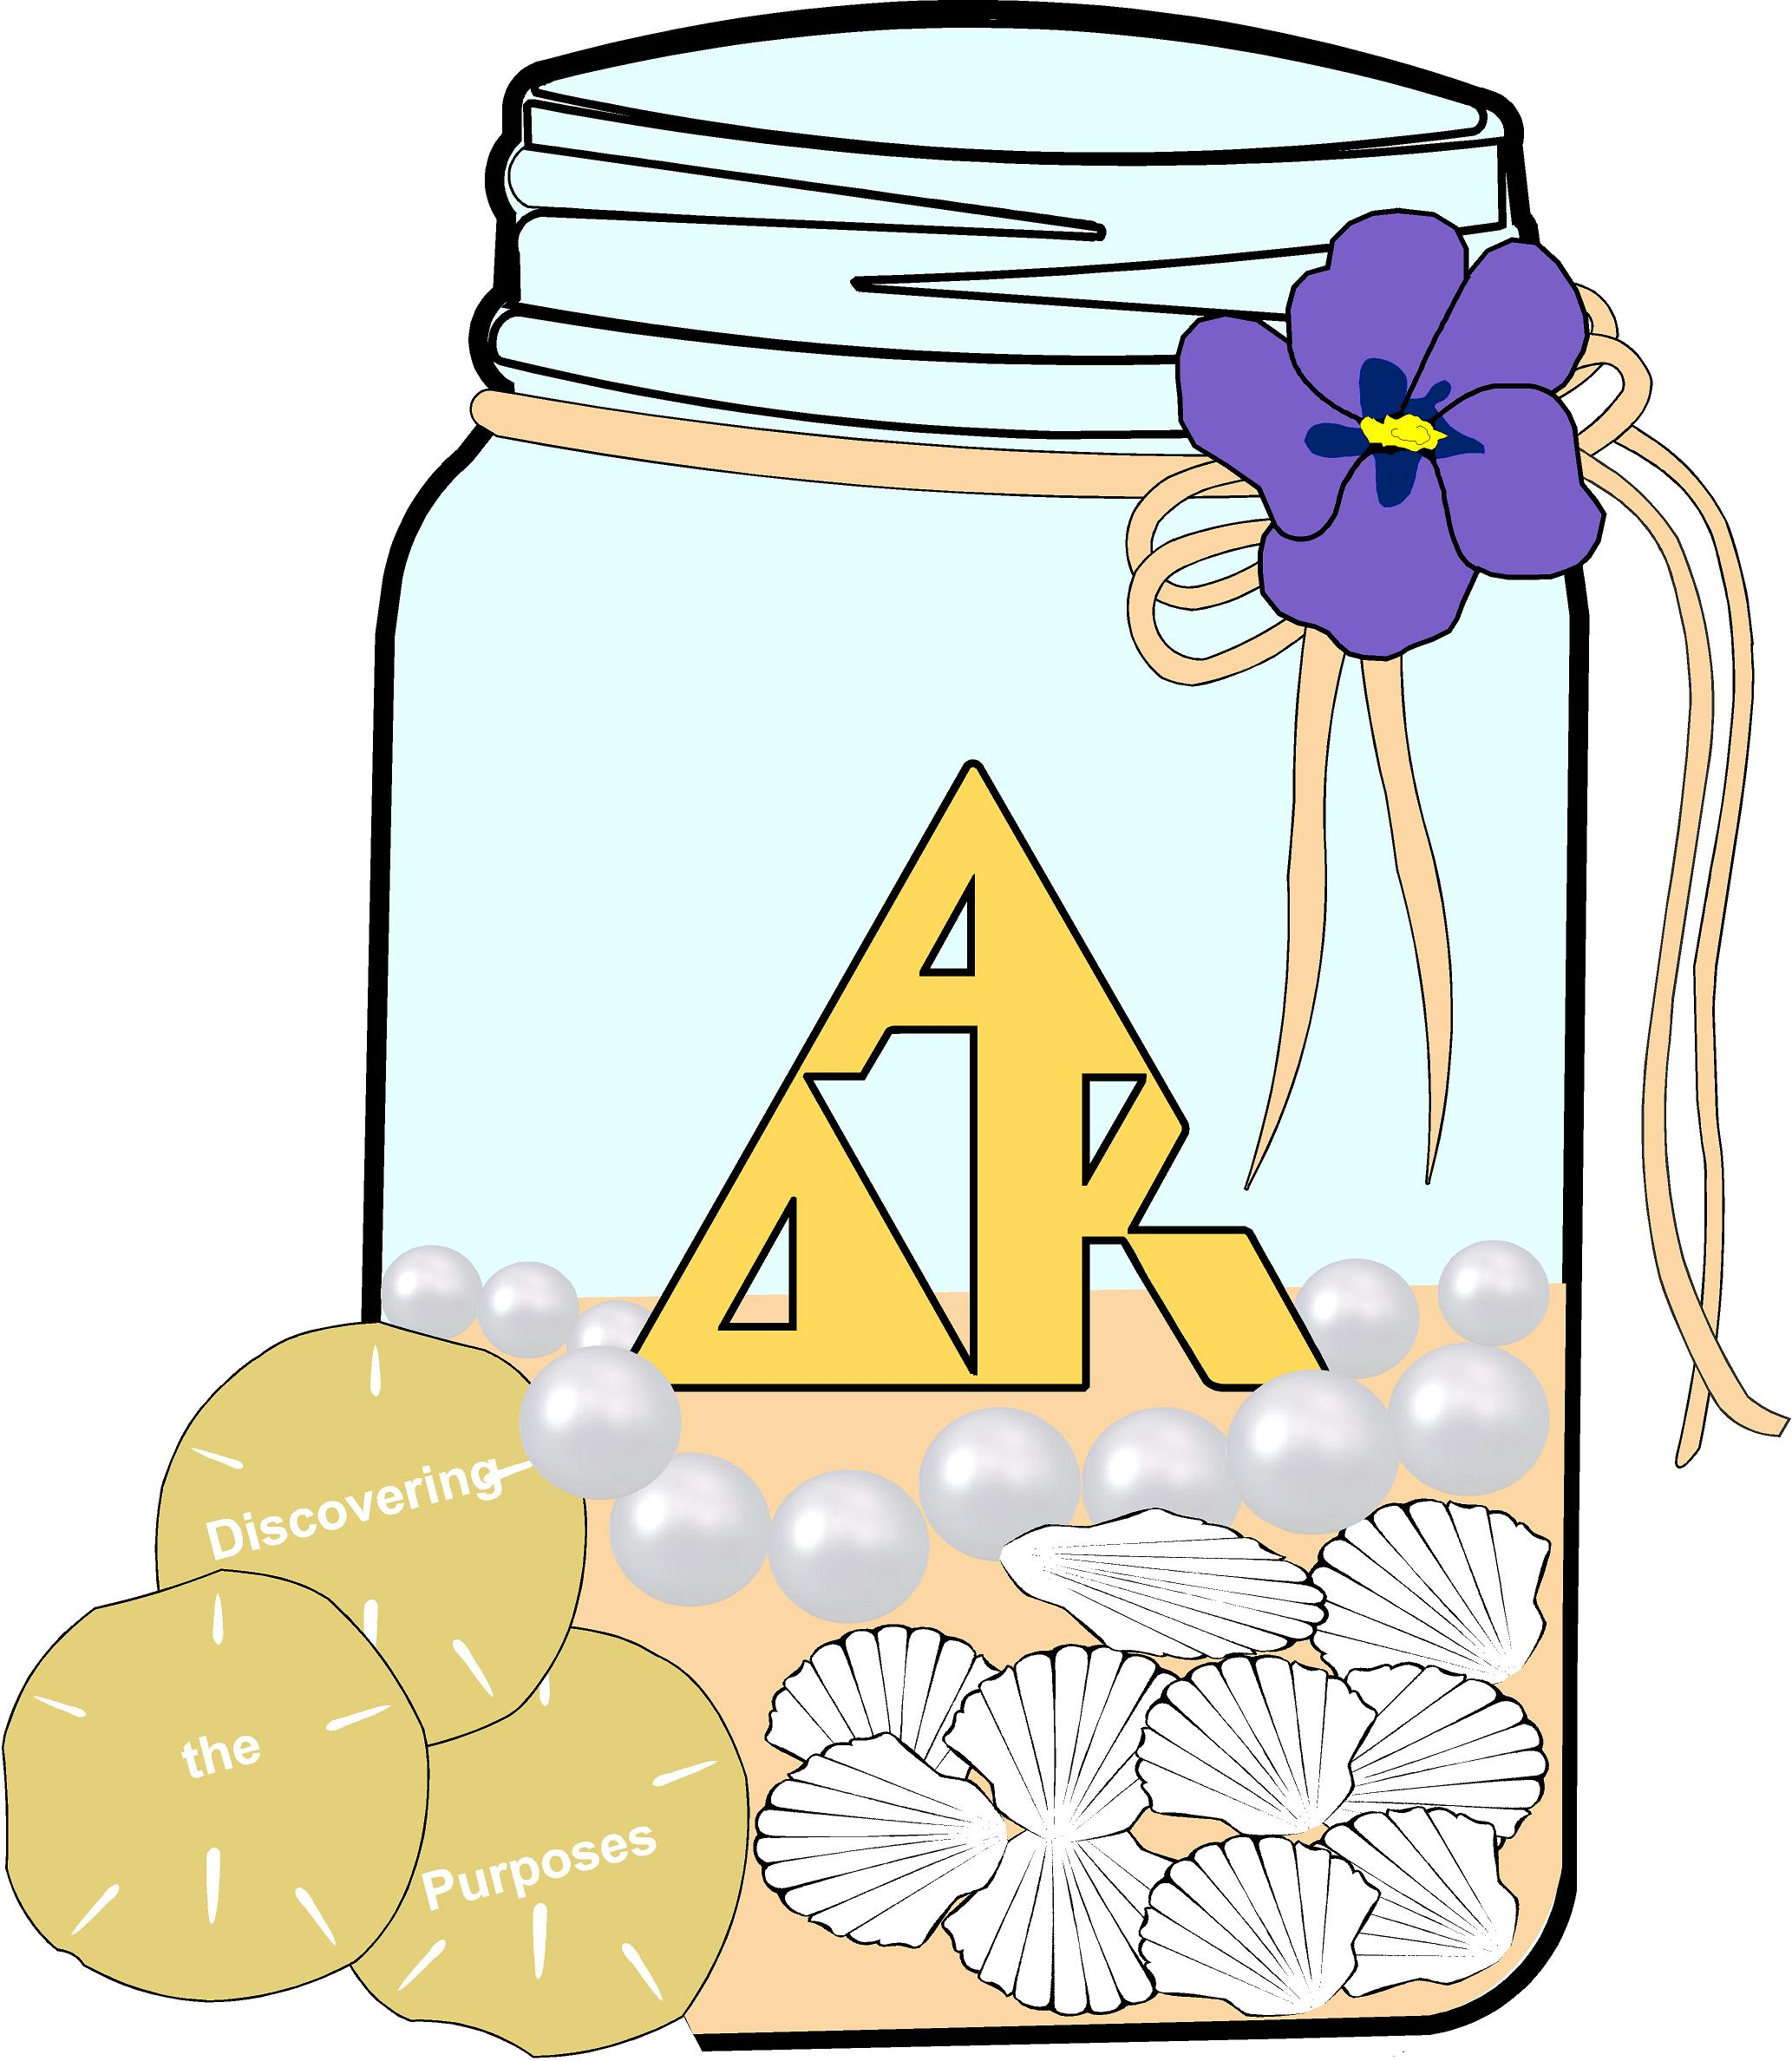
Jan McNeill
Dalton District Chairman
2018 - 2020
April 16, 2020

Officer Responsibilities:
*Kept a running chart of all required forms, minutes, and newsletters for 10 chapters; reminded all continually what was due from each *March 2018 and 2019 – planned District Annual Budgets with committee and treasurer; set up new line items as needed to adjust demands on spending needs *April 2018 State Convention – discussed plans and ideas with other district chairs; sent info to State President concerning district chairs throughout biennium and shared information as needed with chairs, including a reminder to send in District Guidelines; worked with Athens and Augusta District Chairs to plan and organize table decorations for Fun Day for which I assembled dozens of miniature MN flags and ordered tourist info and maps; shared both MN maps with sisters at Fun Day and in MN and MN flags with State President-Elect Norma Rushing; organized supplying 250 bags of chips and needed empty boxes for Fun Day 2019 *May 2018– Set up details for June 21, 2018 Dalton District Executive Board Summer Meeting; planned June 2019 Executive Board Meeting which was later cancelled *Chose logo and theme; shared with all chapters as short newsletter *Contacted by email all chapter presidents, district officers, and 10 mentors to introduce self; sent out reminders for both June 2018 State Leadership and District Executive Board Meetings; emailed detailed information concerning District Executive Board Meetings and General Meetings in October 2018 and 2019 and March 2019; relayed all info concerning Gulf Regional 2018, Fun Day 2019, International 2019, State Convention 2020, and Gulf Regional 2020 *Sent all contact lists to presidents and district officers: State Executive Board, State Advisory Council, and birthdays as well as all Dalton District Executive Board contact information *Relayed all emails from State President and other state officers to presidents and district officers, including all lists and reminders of due dates with accompanying forms. (Dalton District has been 100% in turning in every form and in meeting every due date throughout the biennium!) *Dalton District raised $1500+ for Project Teach Too in 2019 *Communicated continually with State President and my chapter presidents and district officers; many detailed emails were written as newsletters without pictures; was available to answer all questions and help with concerns as any were mentioned *Mentored all ten chapters, visiting all within the biennium at least once; attended all Beta Phi Chapter meetings; attended 2019 and 2020 Tri-Chapter local meetings; sent congratulatory cards to those chapters which added new members in 2019 and to those which were honored as 7-Pearl Chapters at Gulf 2018 and at International 2019; sent birthday cards to District Executive Board *Planned all district meetings, collected and copied needed papers, for each meeting set up 25 notebooks for Executive Board; worked closely with host chapter to plan each meeting and help with any questions or problems; gave out thank-you gifts to visitors and District Executive Board members; planned celebrations with personal poem for chapter celebrations for both Alpha Delta (60th) and Gamma Beta (30th) at two District Meetings *June 15, 2018 – attended State Leadership Workshop; June 21, 2018 – attended and presided over Dalton District Executive Board Summer Meeting; September 15, 2018, and September 21, 2019 – attended State Advisory Board Meetings; April 26-27, 2019 – attended State Executive Board Open Meeting and Fun Day; attended and presided over Executive Board Meetings and General District Meetings in October 2018 and 2019 and March 2019; attended State Chairmen and Chairmen-Elect meeting in January 2020 *Set up hostesses for the GA Suite breakfast on Saturday, June 30, at 2018 Gulf Regional; helped as host *After sending out Dalton District Guidelines with suggested revisions for Executive Board to review, vote was taken to accept October 2018; I retyped and sent revised 2018-20 Guidelines to Executive Board as well as to Margie Winkler, State Bylaws Chairman *Completed and sent in Dalton District Report in September 2018, April 2019, and September 2019.
Conferences and Conventions:
*Attended Gulf Regional Conference in Montgomery, AL, June 29-July 1, 2018 *Attended Fun Day 2019 *Attended International Convention 2019 in Minnesota; helped in GA Suite.
Other Activities:
*Installed 2018-20 chapter officers for Beta Upsilon, Gamma Beta, and Beta Phi *Invited four educators to join Beta Phi; continue to contact each *Attended retirement reception for Beta Phi sister in April 2019 *Donated items and/or money to altruistic project of host chapters at District Meetings and money to Longest Day for GA Alpha Delta Kappa Alzheimer’s Team online *Participated with Dalton District Violets Team in the Alzheimer’s Walk September 2019 *Attended 50th Anniversary Celebration of Gamma Beta, Atlanta District, in June 2019 and its chapter auction in Fall 2019 *Completed hundreds of volunteer community service hours in name of Alpha Delta Kappa.
Closing Statement: I have enjoyed the constant contact with my Dalton District chapter presidents and officers as well as communicating with several other sisters throughout the state, region, and nation, especially with the state officers. My leadership and organizational skills have expanded throughout this biennium. I have loved getting to know and working with my wonderful Dalton sisters. Dalton District has definitely written its own new and exciting adventure book in Alpha Delta Kappa - one page at a time – and we’ve all learned that “Adventure Develops Knowledge”- together!

