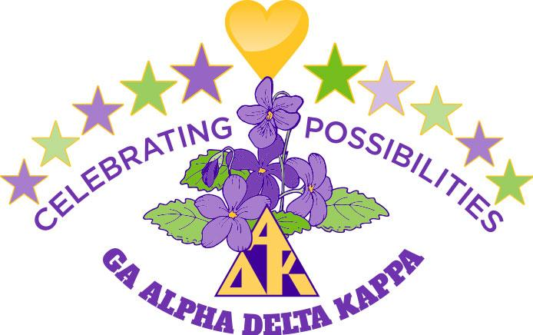
Officer/Committee Chairman Report
Name: Norma Rushing
Position: President
Date: April 22, 2022

Officer Responsibilities
Attended 66-chapter meetings by zoom or face to face.
Attended Beta Iota’s 50th Celebration and will attend Beta Theta and Bets Eta’s 50th Celebrations.
Organized and hosted the Executive Board Summer Retreats
Worked with Debbie Boswell, Pam Parmer, and Janet Robison to secure a location for the 2022 State Convention.
Had 2 site visits to Callaway Gardens Lodge.
Assigned articles for the monthly State newsletter.
Monthly read chapter minutes and newsletters and responded to each.
Planned and conducted all Executive Board meetings for the biennium.
Recorded for the Cornucopia Award chapters who submitted the GA 104, H 107, GA 114, GA 101, and attendance at the All Regions Virtual Conference and International Convention.
Worked with Dawn Hudson to design the State AΔK Newsletter
Wrote Articles for the State AΔK Newsletter.
Had conversations about responsibilities with committee chairman.
Returned calls and emails with chapter presidents and members.
Communicated with Regional and International Officers.
Attended International, regional, and state zoom meetings.
Worked with Debbie Boswell to help plan Fun Day.
Tried to be an encourager to chapter presidents and others.
Attended all districts meetings.
Promotes Colligate clubs with chapters and districts.
Planned the programs and wrote the scripts for state convention.
Worked the organizing committee of state convention to finalize plans for the convention.
Sent cards and letters to the Executive Board and Advisory Council.
Installed 2022-2024 officers at numerous district meetings.
Worked at completing all the duties of the president listed in the Policies and Procedures Manual.
Conferences and Conventions
Attended Virtual International Convention
Attended Virtual Regional Conference
Attended 2021 GA Fun Day
Other Activities
Mentored Nu Chapter’s President Linda Johnson
Attended Sara Ann Birdsong’s funeral.
Participates in Book chats with Pages and Pearls International online Book Club.
Participates in the International “Connect” program.
Sends gift cards and cards to our ITE student Ranata.
Reviewed and scored applications for the Gulf Region Professional Development and Grants Committee.
Will be the Co-Sargent of Arms at the Gulf Region Conference in July.

Closing Statement/Goal
My goal was to keep the lines of communications open between the districts, chapters, and the state. I wanted to see at least 1 if not 2 collegiate clubs organized during my biennium, but COVID interfered with organizing chapters. At the present time 98 to 99% of all reports have been filed on time. I felt privileged to follow the great former leaders of Georgia Alpha Delta Kappa and hoped in some ways I achieved their leadership achievements.

