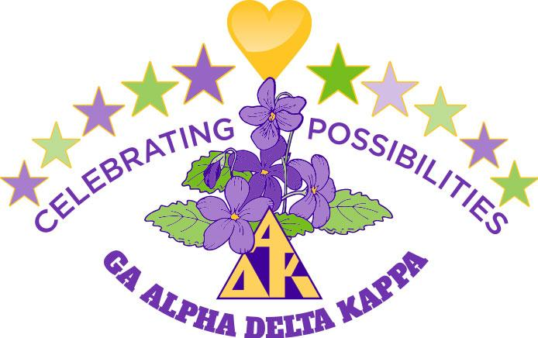
Officer/Committee Chairman Report
Name: Suzi Bonifay
Position: GA VPM
Date: 4-14-2022

Officer Responsibilities
- Collected GA 104 and 105s
- Analyzed data from H-114
- Zoomed with Membership Team – helped draft SMART goals
- Collected membership materials from D Boswell
- Participated in ongoing Telecommunication Team Zooms with Boswell, Hudson & Rogers
- Participated in Newsletter training Zoom
- Participated in June Exec Board meeting via Zoom
- Participated in July Leadership Retreat via Zoom
- Downloaded files from International and shared with Boswell, Hudson & Rogers
- Updated changed email addresses in spreadsheets
- Sent emails to all CPs requesting a change from school to personal email addresses
- Corresponded with individuals and chapters regarding transfer requests and interest in joining requests
- Helped review Policies and Procedures
- Created YouTube training video for Membership Chairs
- Participated in a series of four Zooms with International and the NWR on the creation of Collegiate Clubs (solicited participation form sisters working at the post secondary level)
- Communicated bi-weekly during August with CPs, MCs and periodically with District Chairs
- Participated in District Zoom trainings for MCs with Golden Isles, Heart of Georgia and Albany
- Participated with Gulf Region SMCs and Debby Stubing via zooms and emails regarding membership information, forms, reports and ideas
- Prepared the CNA report for distribution
- Crafted a monthly article for the state newsletter
- Crafted a Membership Newsletter to be distributed periodically
- Crafted documents to address the needs identified on the CNAs to include attendance, recruitment, reinstatement, retention, new chapter development, leadership and programs
- Worked with two chapters regarding struggles and options that include revitalization, merging or disbanding via multiple phone calls, emails and zooms
- Zoomed with the Membership Team on CNA results, CCs, and struggling chapters
- Assisted local Fidelis chapter in hosting a zoom for their September meeting

October 2020-April 2021
- Successfully assisted Alpha Chi and Alpha Xi in merging with Beta Theta and Alpha Nu, respectively
- Continued monthly Gulf Region membership Zooms and crafted responses for a yet-to-be published Membership Consultant’s Toolbox--items 2 & 4 (methods for determining if assistance is needed and steps/examples to engage in active listening).
- Participated with Jamaica sisters in their meeting and fundraiser
- Participated in regular communication team meetings/zooms and more recent Fun Day meetings/zooms
- Participated in spring District meetings and shared membership updates
- Continued newsletter articles
- Provided Zoom trainings and distributed e-packets for New Member & Reinstatement International dues registration/payment
- Tracked those trained via spreadsheet
- Logged calls with MCs and CPs regarding new member registration and other
- Apprised CMCs about change in CNA due date
- Helped chapters and/or individuals problem-solve
- Shared updates with the Membership team via email or zoom
- Hosted Fidelis Alpha zoom

April 2021—September 2021
- Wrote newsletter articles
- Participated in monthly Gulf Zoom meetings and hosted the July meeting for Minie
- Apprised CMCs about the CNA reports due in May-June 2021
- Tabulated all CNA results
- Crafted CNA summary charts and distributed to State Exec Bd and District Directors
- Helped chapters and/or individuals with issues
- Held zooms or phone conferences with Chapter Presidents, as needed
- Developed an Excel Training Document for the CNA for International and shared with Betty Jo Evers
- Submitted information to Gulf & International as requested
- Sent emails regarding recruitment, reinstatement & retention to CPs and MCs
- Sent information regarding Collegiate Clubs to interested chapters
- Sent cards, emails and other messages to those in need

September 2021—April 2022
- Wrote newsletter articles
- Participated in and hosted monthly Gulf Region Zoom meetings
- Assisted chapters in answering questions and resolving issues
- Zoomed with chapters having membership issues
- Crafted and launched a Georgia Membership Campaign
- Provided a program for Alpha Gamma on Membership and Collegiate Clubs
- Attended a number of District Meetings in person, via zoom or sent a report to be shared
- Provided information to the Membership Team as needed
- Participated in the District Chair Zoom meeting
- Sent email to CPs and MCs regarding membership
- Completed membership information for the Cornucopia Awards
- Collected data and tabulated results for Membership Campaign
- Prepared for First Timers session for State Convention

Conferences and Conventions
- Participated in the All Regions Virtual Conference and break-out sessions on August 28, 29 & 30, 2020
- Participated in Georgia Alpha Delta Kappa’s One Day Celebration, September 2020
- Participated in Georgia Alpha Delta Kappa’s Fun Day, April 2021
- Participated in the International Convention, July 2021

Other Activities
- Attended Executive Board meeting in Atlanta, June 2021

Closing Statement/Goal
My goal is to help Georgia Alpha Delta Kappa fulfill the membership goals for the 2020-22 biennium; assist chapters in answering questions and handling all of their membership duties and responsibilities; craft and submit reports on time; participate in local, district, state, regional and international events; and build a stronger and more vibrant membership.

