APPENDIX M

GEORGIA ALPHA DELTA KAPPA

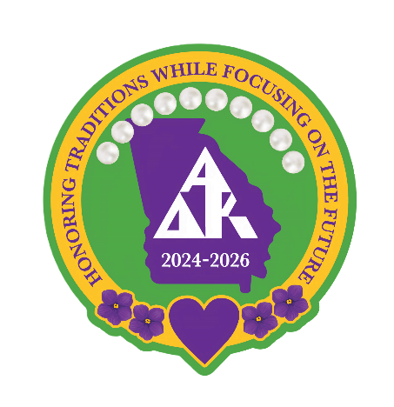
Officer/Committee Chairman Report
Name: Jewel Hendrix
Position: Georgia Disaster Relief Co-Chair
Date: June 1 to May 31, 2026

Officer/Committee Chairman Tasks and Activities Completed to date:
- Secured items to raffle at the district meetings, fun day and state convention to raise money for the DR fund
- Gathered items for Disaster Relief bin
- Formed Committee
  - Spoke with Terri Thompson on August 16, 2024 for details to form committee
  - Broke state into various regions by district, emailed district chairs and asked for volunteers
- Sent email to Golden Isles District Presidents to see if any sisters were affected by tropical storm Debby
- Secured a Disaster Relief table for district meetings, fun day and state convention during biennium
- Placed committee members/members in charge of Disaster Relief table at the district meetings
- Manned Disaster Relief table at fun day and state convention
- Awarded raffle items at Fun Day and State Convention
- Submitted articles for newsletters
- Assisted sisters in need for securing Disaster Relief application, including Zoom meeting for one sister
- Submitted 15 applications with recommendation for approval
Conferences/Conventions Attended in Current Biennium to date:
- July 13 - 16, 2024 Attended Gulf Regional Conference in Dunwoody, Georgia
- 2025 Fun Day
- 2006 Georgia State Convention

Other AΔK Activities participated in this Biennium:
- Served as Golden Isles District Past Chair Elect and VP for Membership
- Served as Georgia Alpha Gamma Fraternity Education Committee
- September 21, 2024 Attended Fall State Meeting
- September 2025 Attended Fall State Meeting
- Attended 2 Golden Isles District Meeting
- Hosted 2025 Golden Isles District Meeting (helped with planning meeting, etc)

