GEORGIA ALPHA DELTA KAPPA Executive Board Officer/Committee Chairman Report
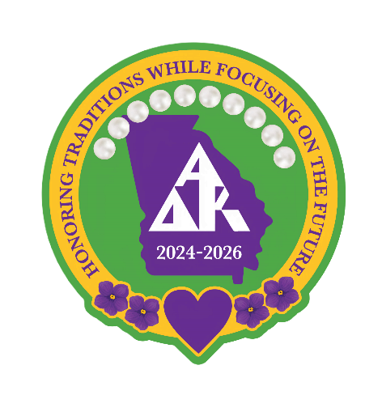
Officer/Committee Chairman Report
Name: Pat Smith
Position: State President Elect
Date: SEPTEMBER 21, 2025- May 1, 2026
Officer/Committee Chairman Tasks and Activities Completed to date:
- I fulfilled my responsibilities as outlined in the GA Policies and Procedures Manual.
- Followed through with requests made by President Terri Thompson.
- Attended and followed through with Zoom meetings with State, Gulf, Regional, and International.
- Maintained contact with GA Ex Bd/Advisory Council, Chapters and Districts…helping when requested to do so.
- Went to several Hotel visits for 2026 Convention.
- Participated in the 1st Steering Committee for 2026 Convention.
- Went to all Fall Districts Meetings. Went to 9 Spring District Meetings
- Attended three more steering committee meetings.
- Zoom meeting in Jan. with District Chairman and Elects.
- Went to Hotel three times.
Conferences/Conventions Attended in Current Biennium to date:
- Attended the 2025 GA State Convention, Alabama FUN DAY and ADK International Convention
Other AΔK Activities participated in this Biennium:
- I helped Debbie Boswell and Erin Neal with whatever they needed during International Convention (setting up, running errands, allowed my car to go on hospitality runs, drove items to and from International Convention)
- Participated in numerous virtual zooms such as: GA Executive Bd Mini Retreat, Disaster Relief, etc.
- Participated in VIRTUAL International Conventions and /or zooms such as: Bylaws Consideration, Candidate Speeches, Robert’s Rules of Order, Sgt at Arms, International Bylaws Amendment Zoom, Town Hall zoom, etc.
- Registered and voted for Current International officers and updates.
- Fulfilled responsibilities as a Beta Theta sister and Past Columbus District Chairman.
- Attended Beta Theta Chapter meetings and visited Beta Gamma Chapter
- I attended all meetings with Stainbeck for Gulf PE’s.
It is a pleasure to be a part of GA Alpha Delta Kappa, Pat Smith

